STANDARD OPERATING PROCEDURE
Use this form to document the Health and Safety information associated with the procedure.

Procedure Title |  | Phosphorous Solubilization Assay
Dept | ABE |  |  | Bldg/Rm | 4210 Sukup |  | Supervisor | Adina Howe

Procedure Overview (brief description of the project)

To determine if a bacteria isolate is able to solubilize phosphate.

Health and safety information for materials used (briefly describe the hazards associated with the materials and/or equipment OR document your hazard assessment in Section I)

Bacteria used in this assay are typically isolated from the environment (plant or soil samples) and are poorly characterized. Pathogenicity is a very low but non-zero risk. Observe at least BSL1 precautions.

No hazardous products are present in the media.

Hazard Control Measures
Please select which type of lab coat, eye protection, and hand protection will be used (Lab coat, eye and hand protection, and closed toe/heel shoes must be selected as required by Section D of the ISU Laboratory Safety Manual.)
 | Latex gloves |  | Insulated gloves |  | Face shield |  | Respirator
 | Nitrile gloves |  | Safety glasses |  | Lab coat |  | Fume hood
 | Neoprene gloves |  | Vented goggles |  | Apron |  | Biosafety cabinet
 | Vinyl gloves |  | Splash goggles |  | Dust mask |  | Glove box
 | Fully enclosed shoes |  |  |  | Flame resistant lab coat

Other Control Measures

Wash hands before leaving the lab

Methods (Include step by step instructions detailing the process or attach this document to an existing method.)

- Prepare Pikovskaya’s agar (PVK) as directed by the manufacturer.
- Grow isolates in preferred broth. For the SynCom isolates, R2A works well.
- Measure OD600 of isolates and dilute to 0.1 with preferred broth
- Label PVK plates
- Place four dots, each containing 5 µL of isolate on the plate. See image for spacing example (image plate has undergone 7 days of incubation)

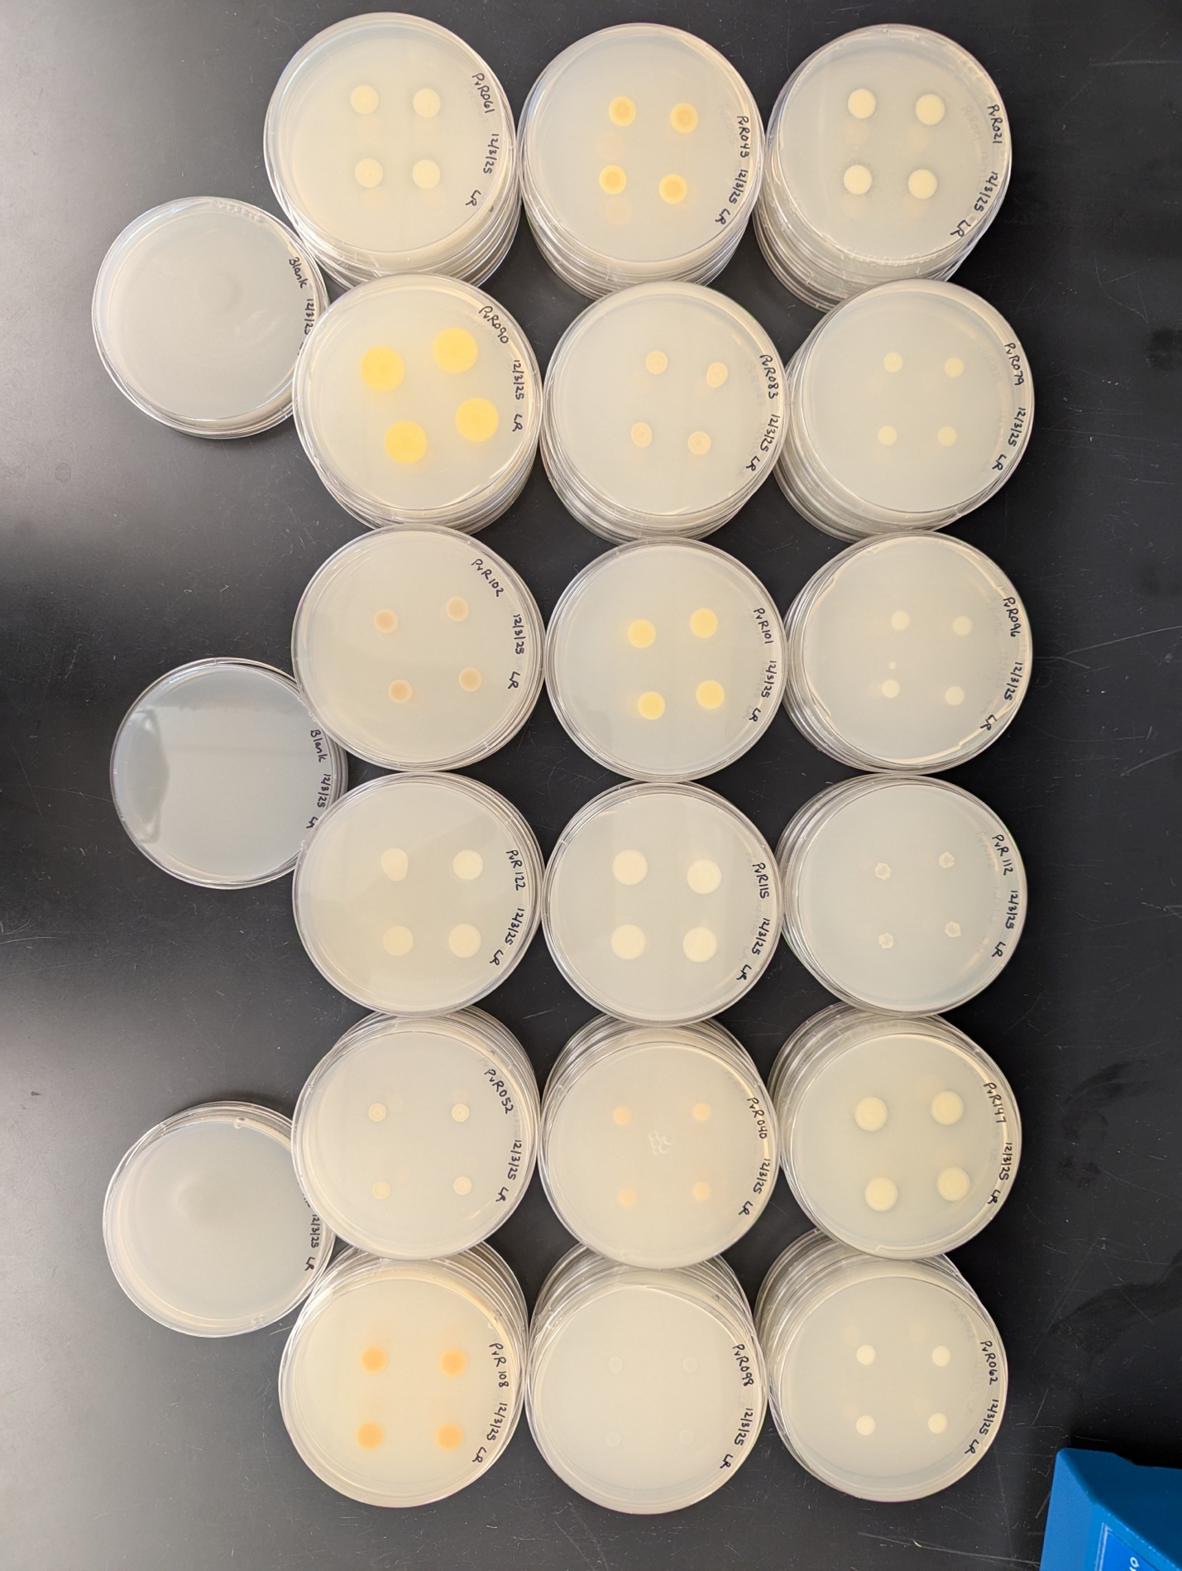

- Parafilm the edge of the plates and place them in an incubator at the preferred temperature. For the SynCom isolates, 29°C works well.
- Incubate plates for 7 days
- Check plates, look for a clear zone around the isolate. Isolates with the zone were able to solubilize the phosphate in the media. Record which isolates contain the zone.
- Put plates back in the incubator.
- Incubate the plates for another 7 days (14 days total). Check the plates and record as above.
- Dispose of plates in biohazardous waste.

Waste Disposal Procedures

All bacteria waste should be sterilized before disposal. Dispose of used plates in biohazardous waste

First Aid Procedures

General advice: Consult a physician. Show this safety data sheet to the doctor in attendance.
If inhaled: If breathed in, move person into fresh air. If not breathing, give artificial respiration. Consult a physician.
In case of skin contact: Wash off with soap and plenty of water. Consult a physician. In case of eye contact Rinse immediately with plenty of water for at least 15 minutes. Consult a physician.
If swallowed: Never give anything by mouth to an unconscious person. Rinse mouth with water. Consult a physician.

Spill/Release Containment, Decontamination, and Clean Up Procedures

Spilled bacteria should be treated as a biohazardous spill.

Using Substances Requiring Special Procedures? No Yes
(If Yes; identify authorized personnel, designate a use area and specify specialized safety precautions here. Refer to Section B in the ISU Laboratory Safety Manual for details.)

Written By | Lorien Radmer |  | Date | 1/15/26
Approved By |  |  | Date
(PI or Lab Supervisor)

- HAZARD ASSESSMENT
Use the hierarchy of controls to document the hazards and the corresponding control measure(s) involved in each step of the procedure.

Consider elimination or substitution of hazards, if possible.
Engineering Control(s): items used to isolate the hazard from the user (i.e. fume hood, biosafety cabinet).
Administrative Control(s): policies/programs to limit the exposure to the hazard (i.e. authorizations, designated areas, time restrictions, training).
Required PPE: indicate PPE including specific material requirements if applicable (i.e. flame resistant lab coat, type of respirator or cartridge).

Task | Hazard | Engineering Control(s) | Administrative Control(s) | Required PPE

- TRAINING RECORD
Use the following table to record the training associated with this Standard Operating Procedure.

Print Name | Signature | Trained By | Date

